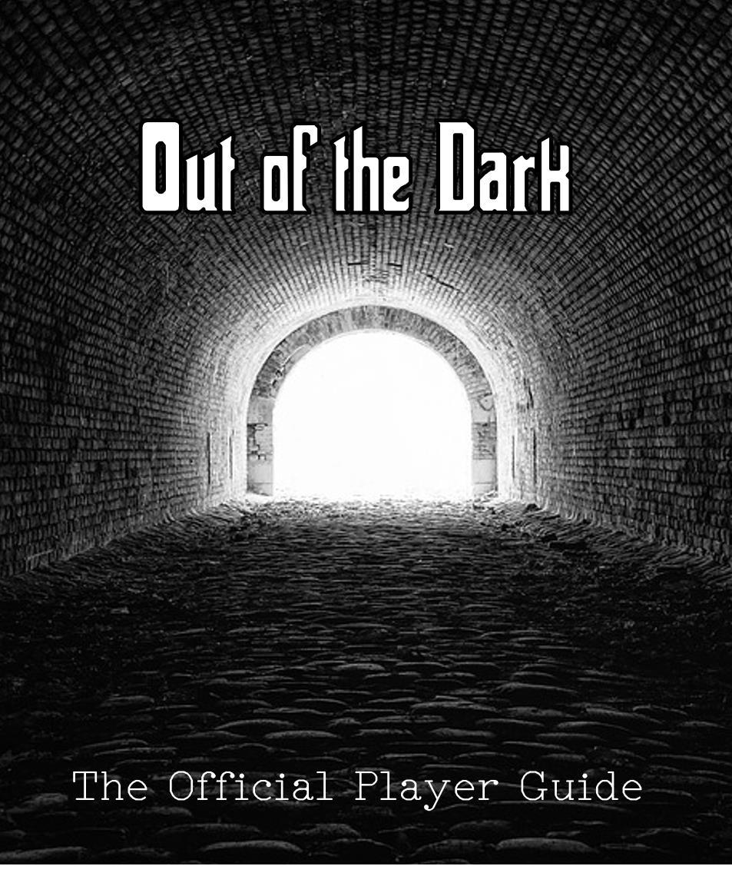

**Out of the Dark** | 1

Contents

The Settings Menu 3

Accessing Settings 3

Changeable Preferences 4

Types of Difficulty 4

The Maze Builder 5

Accessing the Maze Builder 5

Building a Maze 6

Adding Your Maze 7

Playing the Game 8

Winning/Losing the Game 8

How to Move 9

Tile Types and Damage 9

Known Bugs 12

**Out of the Dark** | 2

The Settings Menu

**Accessing Settings**

The settings menu can be accessed from the main menu that displays on launch and during gameplay. Accessing the settings menu from the main menu can be done by simply clicking the “Settings” button as shown below.

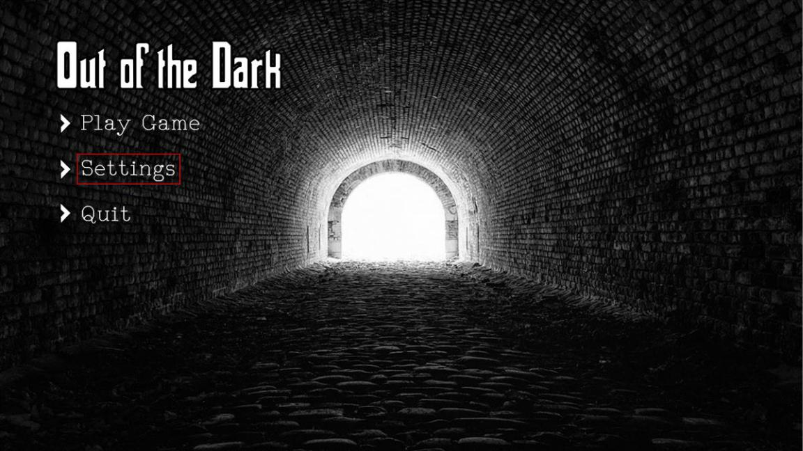

Accessing the settings while playing a maze can be done by pressing the ESCAPE key and then clicking the “Settings” button, as shown below.

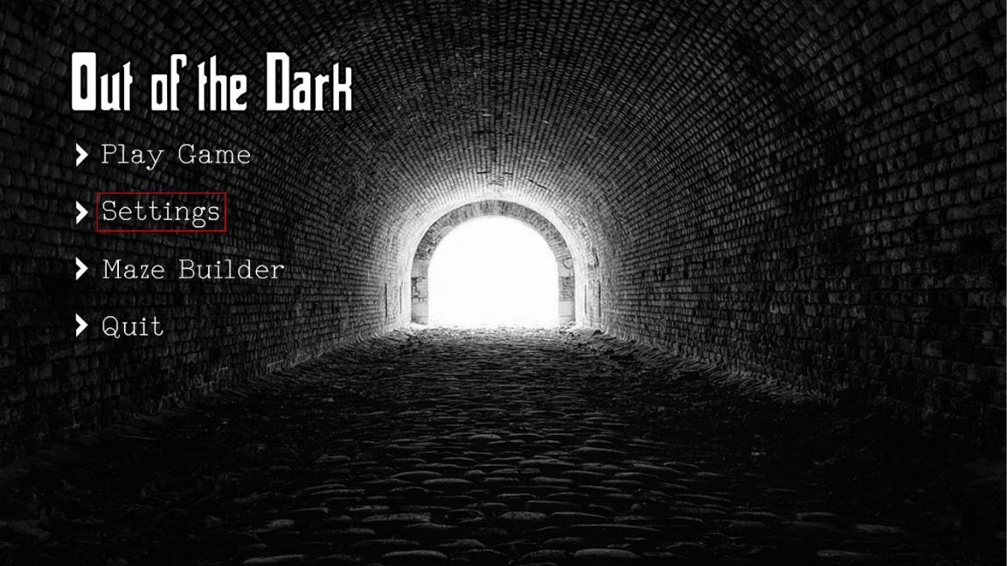

Pressing either of these settings button will cause the settings menu shown below to appear.

**Out of the Dark** | 3

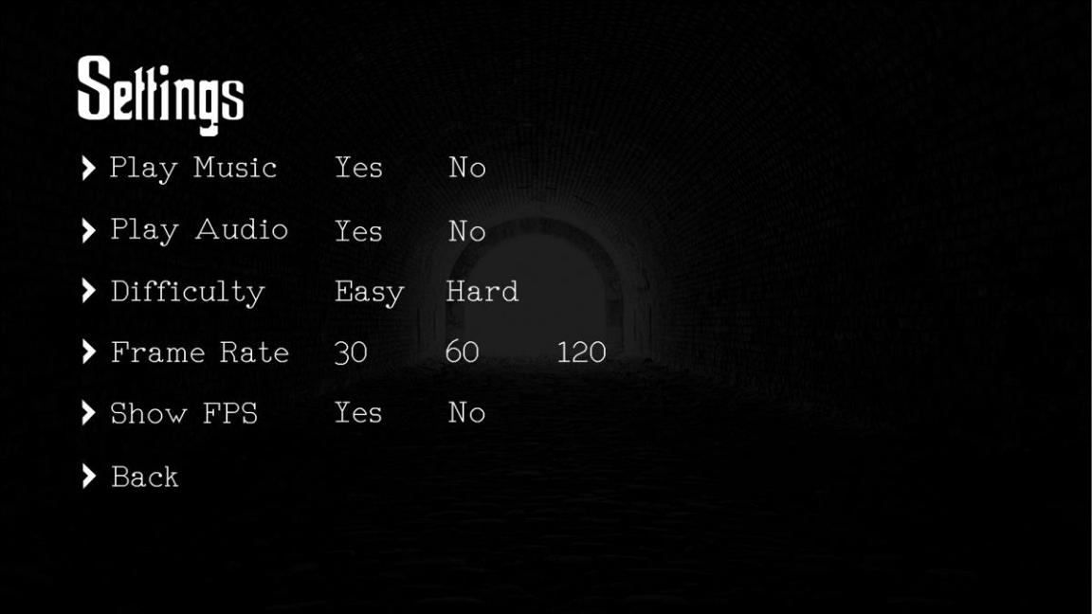

The settings preferences shown in the menu are all changeable, with your current settings preferences being outlined with a white border.

**Changeable Preferences**

Changing a preference simply requires a button press on the new desired setting. No setting can have two different preferences (e.g. “Play Music” cannot be both “Yes” and “No”). After a setting has been changed, the white borders of the currently selected preference for that setting will update. Setting changes are effective immediately after button press, although they will not save until the “Back” button has been pressed, which results in the main menu being displayed.

**Types of Difficulty**

There are two types of selectable difficulties in the settings menu; the selected difficulty can be changed both in the menu and while playing a maze, but a difference will only be noticed while playing a maze.

**Out of the Dark** | 4

The Maze Builder

**Accessing the Maze Builder**

Maze creation requires the “Maze Builder” to be accessed. This can be done by pressing the “Maze Builder” button on the main menu, as shown below.

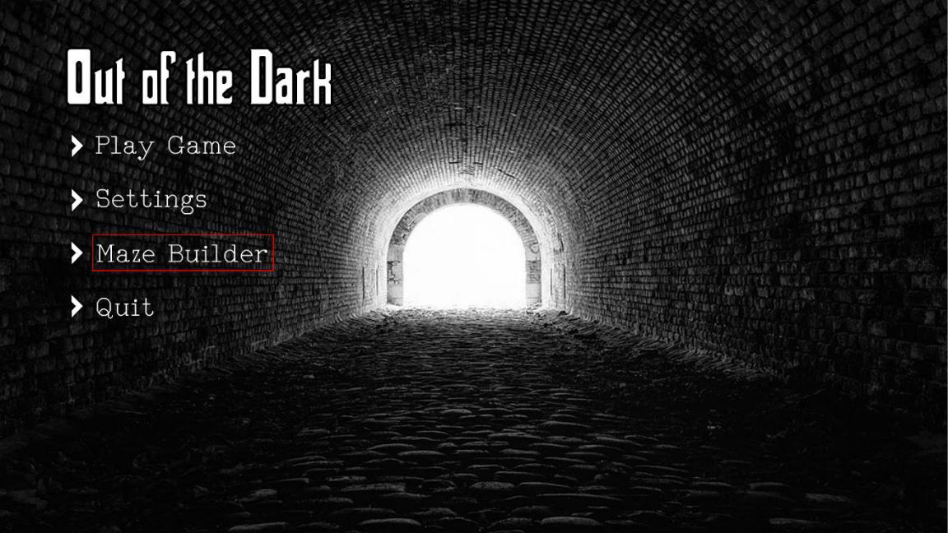

After this button has been pressed, the “Maze Builder” will appear.

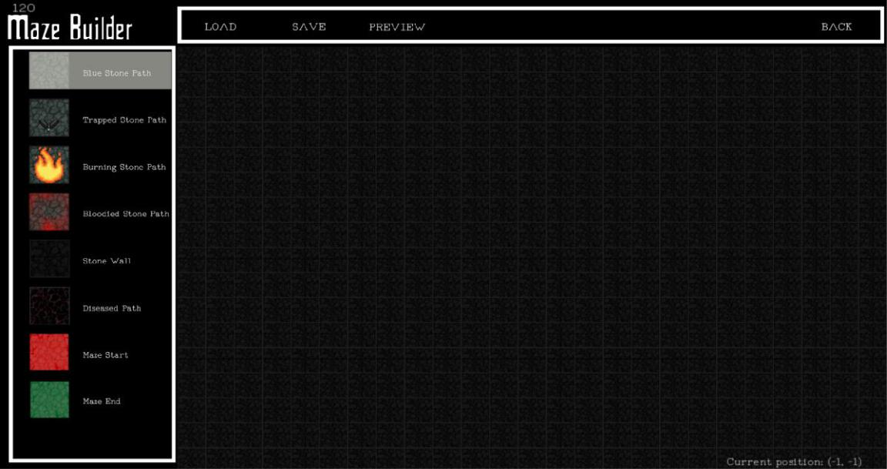

**Out of the Dark** | 5

**Building a Maze**

The Maze Builder has several components that allow complete control over level design; its components can be broken down into the sections shown below.

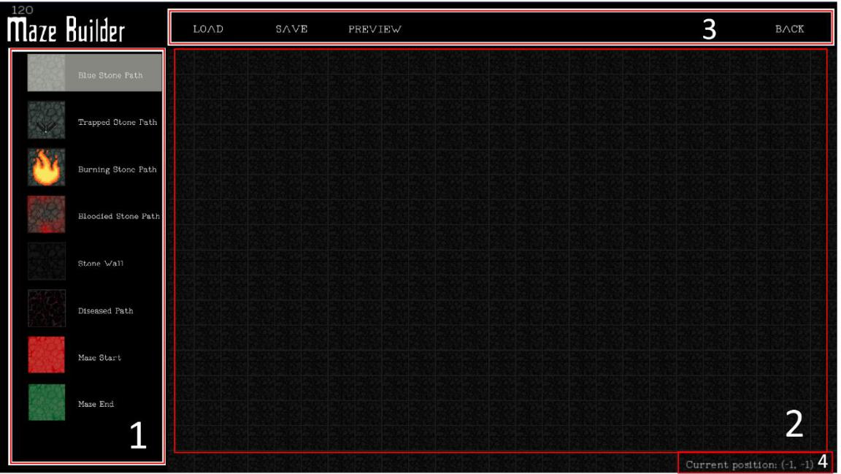

Section 1

The first section of the Maze Builder contains all the placeable game tiles. Any of the tile types can be placed on the grid (section 2). A tile type can be selected by left-clicking on any of the eight tiles in section 1. The currently selected tile is indicated by a transparent highlight (seen above over the “Blue Stone Path” texture). Once a tile type is selected, it can be placed in the grid (section 2) by left-clicking on any of the tiles.

Section 2

The second section of the Maze Builder contains the grid of tiles that forms the maze. Left-clicking in the grid will place whichever tile type was selected on the tile that the mouse cursor is hovering on. The tile that the cursor is over can be easily distinguished by its transparent highlighting. Right-clicking while in the section 2 grid will place always “Stone Wall.” This allows accidental placements to be easily undone.

Section 3

The third section of the Maze Builder contains important buttons for the maze building process. The leftmost button in the section, the “Load” button, can be left-clicked to allow the editing of an existing maze. Pressing the button will open a file explorer that can be used to navigate to a pre-existing maze. The selected pre-existing maze will then appear in the Maze Builder and can be edited. It should be noted that loading a maze will cause any unsaved changes to the current maze to be lost.

**Out of the Dark** | 6

The “Save” button can and should be used to save changes made to mazes that are open in the Maze Builder. Left-clicking the button will open a file explorer; at this point, the maze can be saved in the desired directory. A default folder titled “levels” is present in the “Out of the Dark” directory. This folder contains three default levels

The “Preview” button allows the maze to be seen in a more general sense. Pressing the button will change the size that the game tiles are displayed at to allow a larger portion of the maze to be observed. Pressing “Preview” again will revert the change in scaling.

Section 4

The fourth section of the Maze Builder displays the current position of the cursor in the grid of tiles that make up section 2. All mazes are 512 by 512 game tiles in size by default, meaning the position of (256, 256) is the center game tile.

Helpful Tips

The arrow keys can be used to navigate on the x and y axis in the maze builder. This allows the maze to expand past the game tiles that are initially visible. The “WASD” keys can be used for the same purpose and have the exact same functionality. These navigation keys can be used to place many tiles at once, if left-click is held down simultaneously with one of the navigation keys. It should also be noted that all mazes should have at least one “Maze Start” tile and one “Maze End” tile before they can be played. Placing multiple “Maze Start” tiles will result in the one with the lowest index being chosen for the player’s starting position.

**Adding Your Maze**

Mazes must be first added as one of the three available levels present after the “Play Game” button is pressed from the main menu. Adding a maze requires a right mouse button press to be performed on any of the three level saves. At this time, a file explorer will appear, and a custom maze can be selected. Then, the added maze can be launched by left-clicking on the save slot that it was added to.

**Out of the Dark** | 7

Playing the Game

**Winning/Losing the Game**

The player begins on a red-highlighted tile, known as the “Maze Start” tile in the Maze Builder. A player can win the game by successfully navigating from the red “Maze Start” tile to any green “Maze End” tile. There can be multiple “Maze End” tiles; some may be impossible to reach by design. Players should examine potential end tiles carefully before making a move. Once an end tile has been reached, the overlay pictured below will appear.

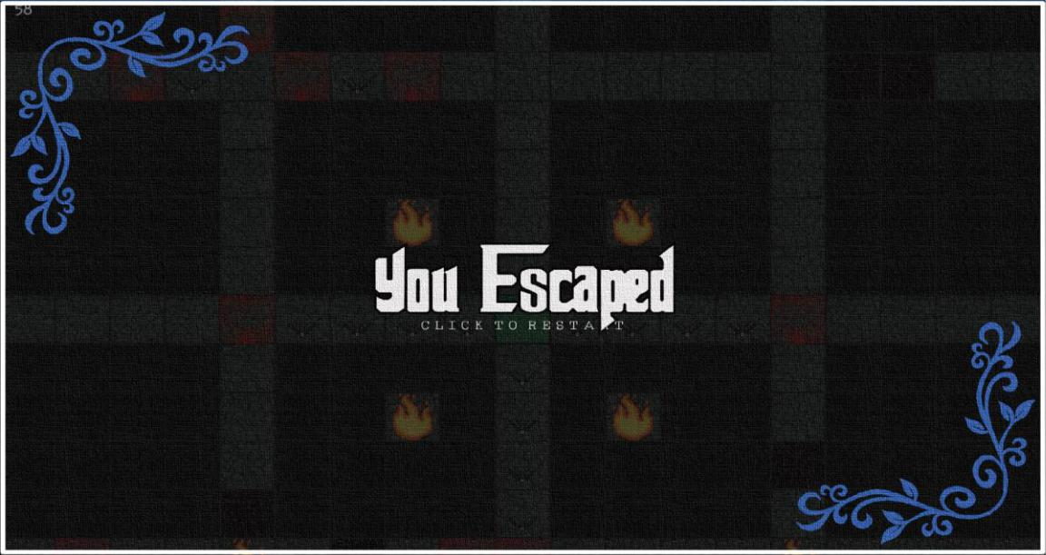

At this point, clicking anywhere will result in the level restarting with the player on the “Maze Start” tile. A similar overlay will appear if a death occurs, as shown below.

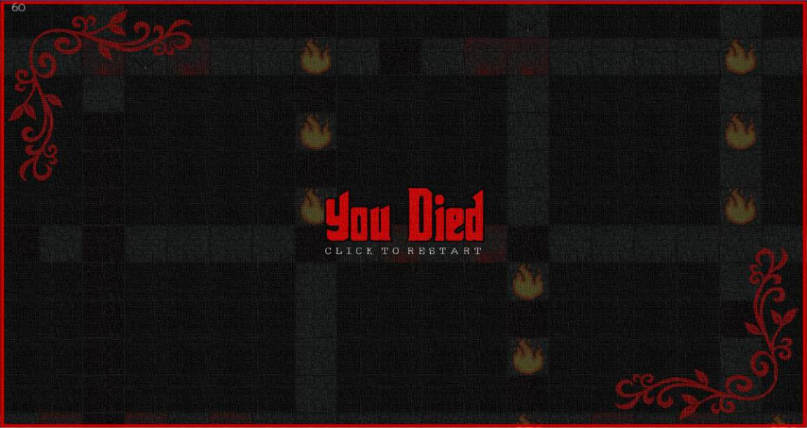

**Out of the Dark** | 8

Death occurs when the player reaches 0 health, from the starting health of 100. The amount of health left can be observed in the health bar in the bottom left, while in game. The green portion of the bar indicates remaining health, while the red portion indicates lost health.

**How to Move**

Any of the desired walkable tiles can be moved to, so long as there is no “Stone Wall” tile

blocking the path from the player’s position to the tile. Movement is performed by left-clicking

on the tile that the player wishes to move to. Once clicked, the player sprite will move towards

the selected square until it is reached or a “Stone Wall” tile is encountered. Collision with a

“Stone Wall” tile will cause the player to completely cease moving. It should also be noted that

the “Diseased Path” tiles will cause the player’s movement speed by half.

**Tile Types and Damage**

There are eight individual types of game tiles in the game, as described below. Seven out of the eight tiles are walkable, meaning the player can move freely from the tile to other walkable tiles.

The “Blue Stone Path” Tile

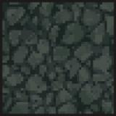

The “Blue Stone Path” tile is the primary walkable tile. The tile causes no damage or other detriments when walked on. The purpose of the tile is to allow the player to move towards the “Maze End” tile. It is recommend that players stay on this tile while not actively moving.

The “Trapped Stone Path” Tile

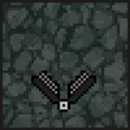

The “Trapped Stone Path” tile is a walkable tile that causes an instant one-time instance of 40 damage to the player’s health. Once the damage has been dealt, the tile will update to become a “Blue Stone Path” tile.

The “Burning Stone Path” Tile

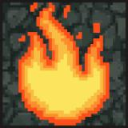

**Out of the Dark** | 9

The “Burning Stone Path” tile is a walkable tile that causes the player to catch fire. Player collision with this tile results in an amount of 5 damage per second being dealt for a total of 5 seconds after the player has left the square. This results in a total of 25 damage being dealt.

The “Bloodied Stone Path” Tile

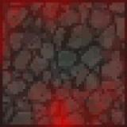

The “Bloodied Stone Path” tile is a walkable tile that is purely for decoration purposes. During maze creation it is suggested that this tile be used near “Trapped Stone Path” tiles to highlight their presence.

The “Stone Wall” Tile

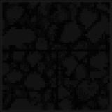

The “Stone Wall” tile is the only non-walkable tile. The player cannot move through or into any “Stone Wall” tile and player movement will cease if such a collision occurs.

The “Diseased Path” Tile

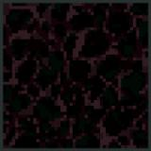

The “Diseased Path” tile is a walkable tile that causes damage to the player for the duration that the player is standing on it. Additionally, this tile causes the player’s movement speed to decrease by half. It should be noted that a player can travel over 14 consecutive “Diseased Path” tiles before the total damage accumulates to over 100.

The “Maze Start” Tile

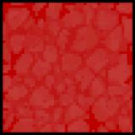

The “Maze Start” tile is walkable and marks the starting position of the player in the game. Only one such tile should be present during the creation of a maze. Attempting to play a maze with

**Out of the Dark** | 10

greater than one “Maze Start” tile will result in the tile with the lowest coordinates being chosen as the starting position.

The “Maze End” Tile

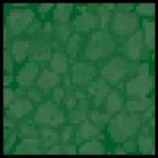

The walkable “Maze End” tile marks the end of the maze and reaching this tile is the goal of the player. Maze levels can have multiple “Maze End” tiles; reaching any of the one or more occurrences of this tile will result in the player winning the game.

**Out of the Dark** | 11

Known Bugs

1. Mazes are currently unable to be saved or loaded if they contain whitespace characters. A temporary workaround is to avoid use of whitespace characters in .maze filenames. This issue is being investigated and a fix will be deployed.
2. A movement bug exists where in some cases a player can force themselves into a “Stone Wall” game tile when moving diagonally. This issue is being investigated and a fix will be deployed.

**Out of the Dark** | 12